Import the Eclipse project into the workspace.

* Either click on Import projects or if it’s not available on the workspace go to File – Import you should see the below

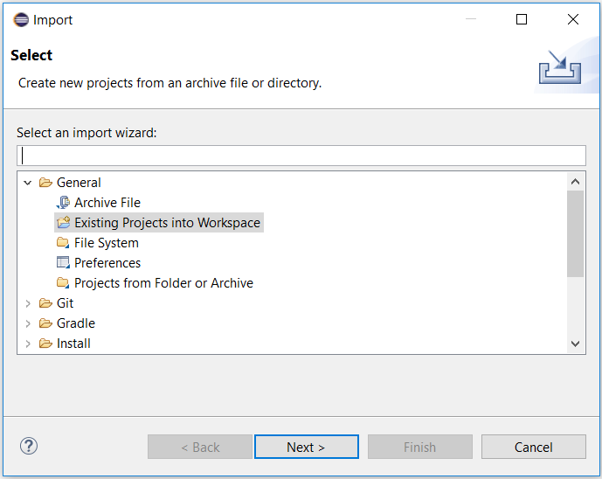

Select **Existing Projects into Workspace**

Click **Next >**

You will see the below window

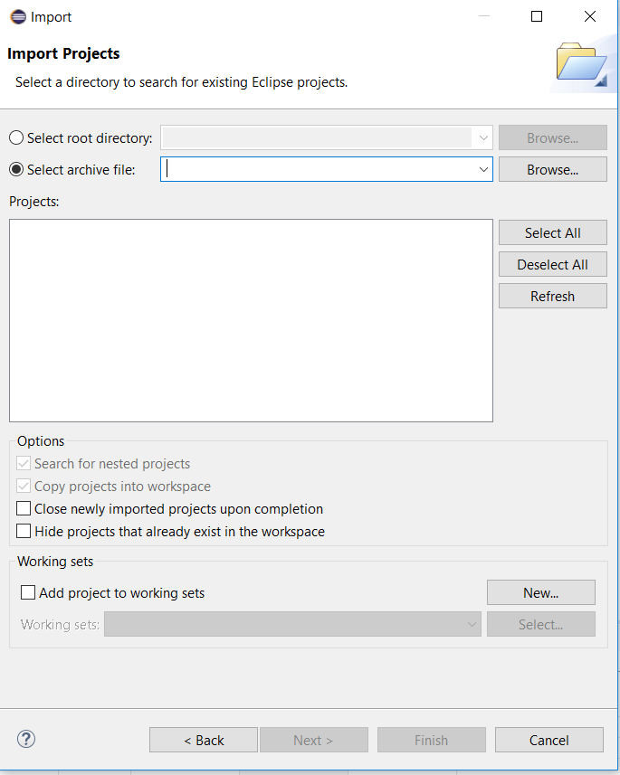

Click **Select archive file**

Then browse to the desired Archived file for example **Development Assignments – Module 5 – Slide Show.zip**

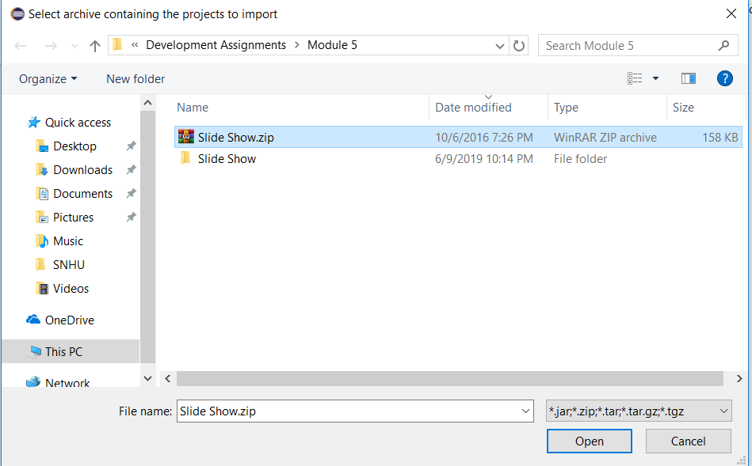

Click **open**

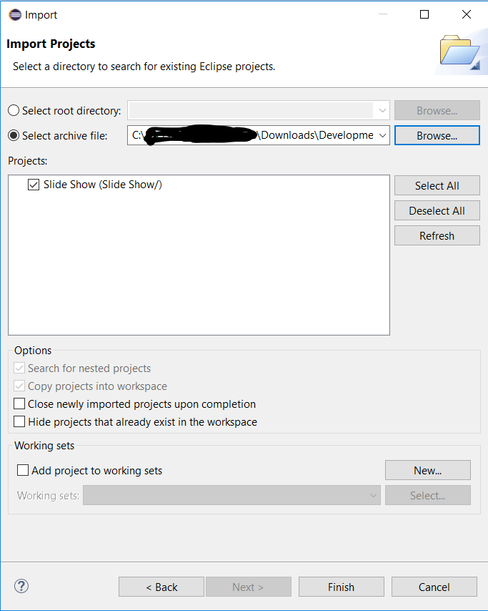

Click **Finish**

You will see this on the Package explorer

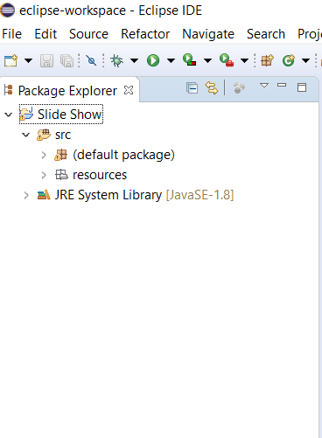

Expand **Default Package** and double click on **Slideshow.Java**

You will be presented with the following screen

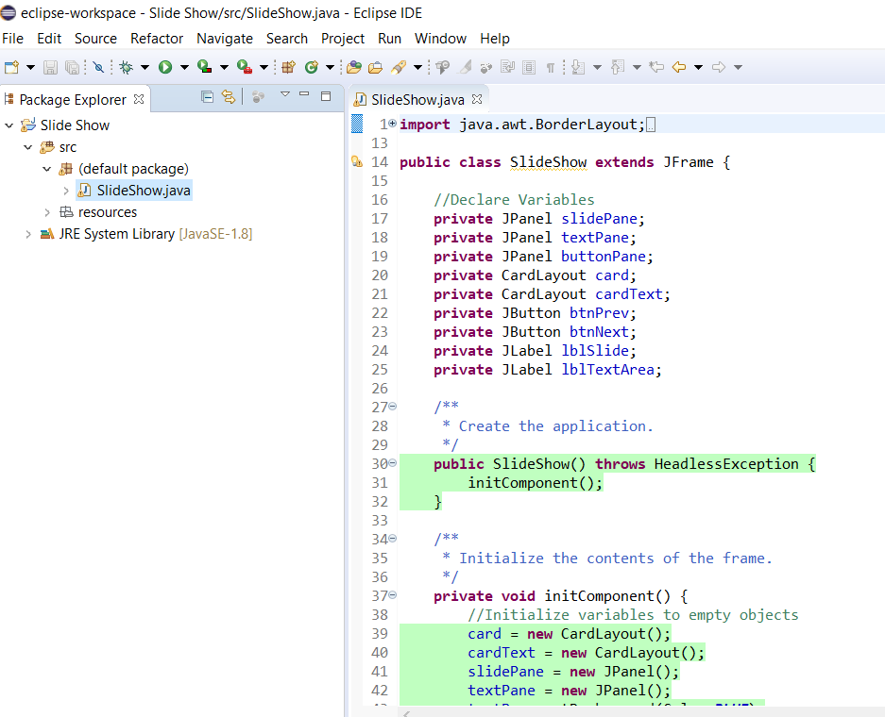

To run the application, click the green run button

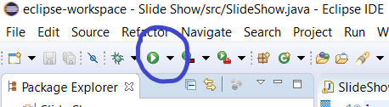

The given wireframe will execute**. Please note that this is the same executable that was given as a jar file in module 4**

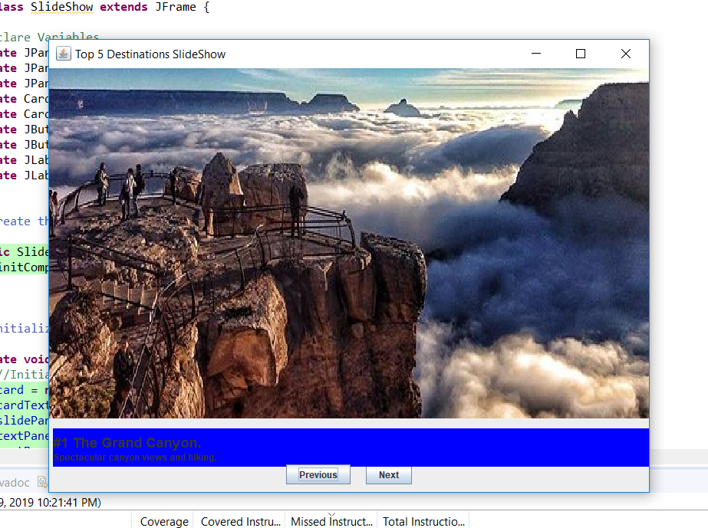

Click **Next** on the application. Take note that the second image and descriptions are missing

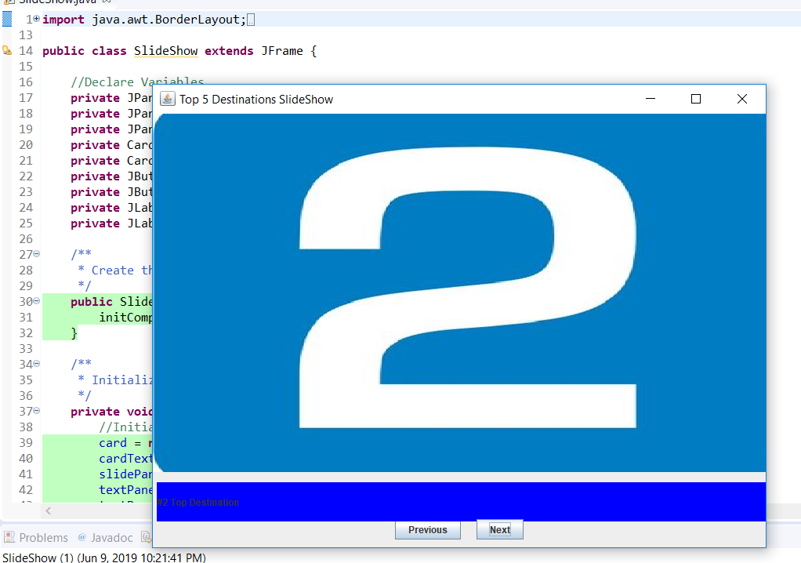

The assignment requires us to add images and descriptions as per instructions. Update the slideshow control with pictures and text for the new requirements specified by the product owner this week. As per the video you are expected to look for Detox/Wellness centers and add them into the slideshow. Let’s do one in this KT.

**Adding the Detox centers.**

1. Search for a Detox and Wellness centers in my case I will use an example of *Kamalaya Wellness Sanctuary, Koh Samui*
   1. Find photos of the centers and save them in your computer and import into the resources folder:
      1. Right Click on Resources

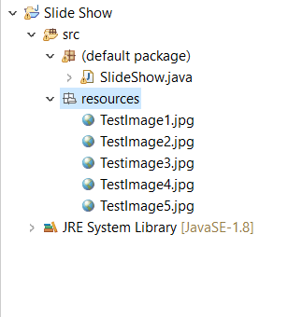

Then Click **Import**. Choose **File System**

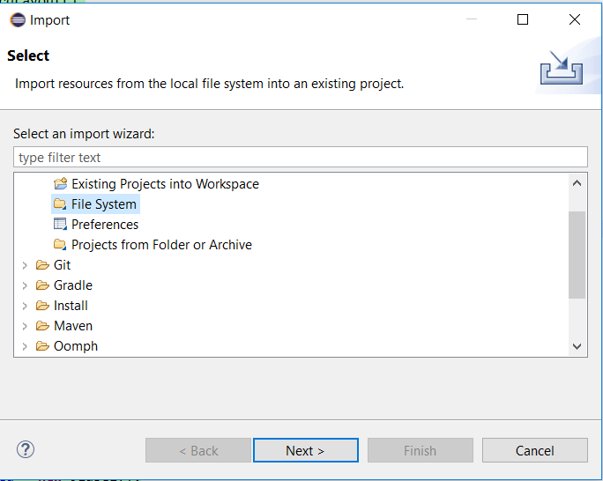

Click **Next**

Click **Browse** and navigate to where you saved your pictures**.**

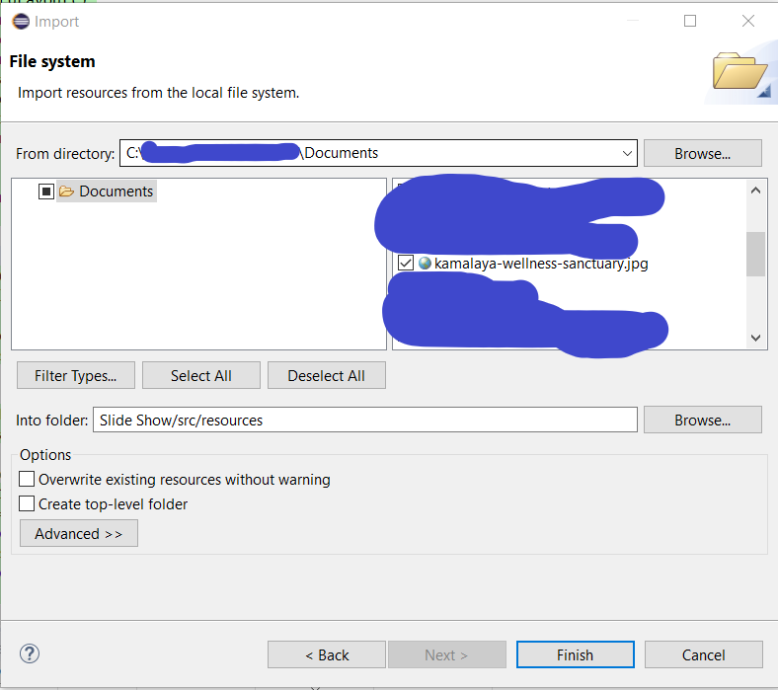

Click **Finish**

Your new Images should now be added under the Resources folder

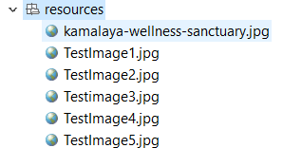

In your code SlideShow.java navigate to the function named **private** String getResizeIcon(**int** i)

This is where you will do your image edits for instance I will change the TestImage1.jpg to the image I just added

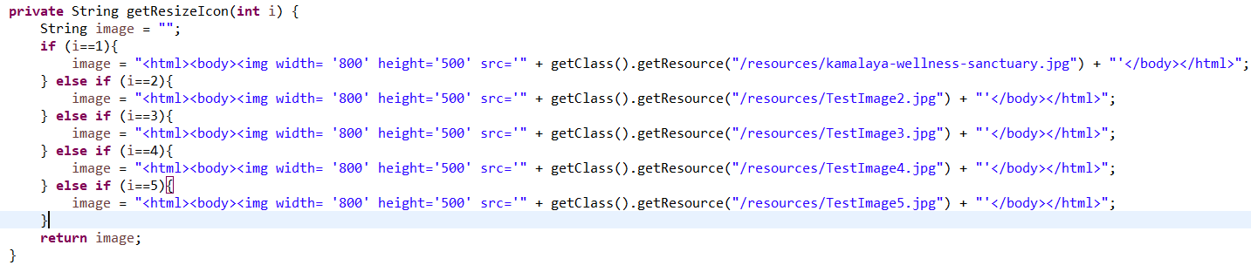

**Please note that you should edit all the images**

Next go to the function named **private** String getTextDescription(**int** i)

This is where you will edit the Description

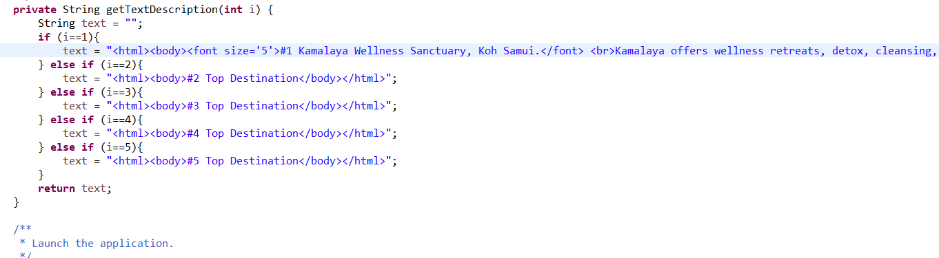

**Please note that you should edit all the descriptions**

Now click Run (The green play button) You should see your changes